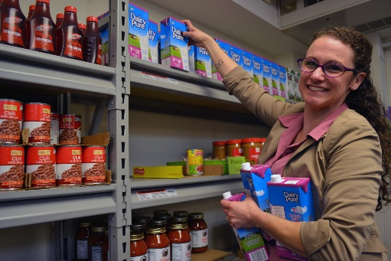As food insecurity has become even more heightened during the COVID-19 pandemic, the College’s food pantry has remained open to serve members of the College community.

“The COVID-19 pandemic has escalated the need for food because of the financial ruin it has created for many people,” said Robyn King, Counselor _____, who oversees the pantry. “Dr. Moono and I decided the pantry needed to remain open to serve every member of the SUNY Schenectady family: students, faculty, staff, adjunct faculty, FSA employees, and Security.”

The pantry is adhering to social distancing and disinfecting, and has scaled back hours. It is open on Mondays from 11 a.m. to 4 p.m. and on Tuesdays/Thursdays, from 1 to 4:30 p.m. Those coming to the pantry are asked to bring their College ID with them.

When visitors come to the pantry they see a caring and friendly face. Jessica Beauchemin, a Nutrition major, has been a Student Worker in the pantry for almost a year. She works with Robyn King to ensure the pantry continues to serve those who need it. “After I went shopping at three different stores and saw shelf after shelf completely barren, I decided that I had to go to work…,” Jessica shared. “If I was experiencing the lack of necessities, then others were experiencing it as well.”

The Food Pantry first opened on campus in ____________________ and has been a great success ever since, serving as a valuable resource for the College community. (We can put numbers here if you think that would be good. What do you think Robyn?)(Also, should we put a line about anything that is needed?)